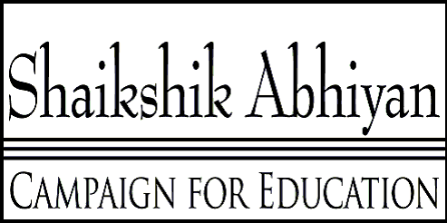

Kathmandu, Nepal

CE is registered with the Government of Nepal in Kathmandu and the Social Welfare Council.

General Instructions to volunteers filling application forms

Based on past experiences, here are some suggestions:

1. Please fill in the form completely. In previous years, many questions were left blank. This hurts the applicants. Without adequate information on the applicant, even genuine students might be denied scholarship since there might not be sufficient basis to evaluate the applicant.

2. The total amount of financial assistance requested is way more than what is reasonable. Please keep in mind that we provide scholarship to students who we think truly needs our help. We also know the approximate amount that is needed to fund a student. We do not provide money to the family members for their other expenses. It needs to be mentioned here that asking more than what is reasonable only lowers the chances of being granted scholarship.

3. Please fill in the form truthfully. It can be relatively easy to catch inconsistencies. This only hurts the chances of getting scholarship.

4. Part II is meant to provide more information to the selection committee so that they can make informed decision. There seemed to be some confusion with question 1 and 2. There can be some families who can not send their children to private schools, but they are able to send them to public schools. Some families can send students to both private and public schools, while others can not send to either type of schools. We want volunteers and coordinators to provide these information here based on what they see and hear.

If there are confusions regarding any of the questions in the form, please ask us instead of just leaving the question blank!

