

Kathmandu, Nepal

CE is registered with His Majesty’s Government in Kathmandu and the Social Welfare Council.

Community Information Questionnaire
2014

The purpose of this community information questionnaire is for the selection committee and the organization to gain a better understanding of social, economic, educational, and infrastructure makeup of the communities in which CE offers its programs. A given area of operation has students from different neighborhood, wards, toles, or villages. Please fill out the questionnaire for each location from which renewal or new applications are being collected. If there are multiple students from one location, you only need to fill out one community information questionnaire for that location. For example, if you have six students from two different villages, please fill out questionnaire for two villages.

Mailing Information
Please mail the application to

Campaign for Education
GPO Box 2259
Kathmandu, Nepal

or you can also email it to
applications@nepalchildren.org

Questionnaire for Rural Locations

1. Your NCEF area (Please circle one of the following areas on the map):

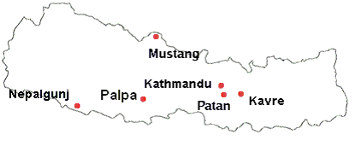
2. Name of the area coordinator
3. Name of the location, tole, ward number, neighborhood, village or community that is described by this questionnaire
4. Name of the existing CE students from this location
5. Name of new students who live in this location for whom applications have been filed
6. How far is the village from the highway or motorable road ?
7. Approximately what proportion of children above 6 do not go to school in this village ?
8. How many public secondary schools are there within one hour of walking distance ? What about private schools ?
9. Does the village have electricity ?
10. How far is the nearest post office ?
11. What are the main sources of jobs in this village ?
12. Approximately what fraction of people have formal education up to SLC and the intermediate level (grade 12) in this village ?
13. What is the ethnic makeup of this village ?

Questionnaire for Urban Locations

1. Your NCEF area (Please circle one of the following areas on the map):

2. Name of the area coordinator
3. Name of the location, tole, ward number, neighborhood or community that is described by this questionnaire
4. Name of the existing CE students from this location
5. Name of new students who live in this location for whom applications have been filed
6. Approximately what proportion of children above 6 do not go to school in this location ?
7. How many public secondary schools are there within half hour of walking distance ? What about private schools ?
8. Does this location have electricity ?
9. Does this location have phone service ?
10. What are the main sources of jobs in this location ?
11. What is the ethnic makeup of this location ?

